FIZEN DELIGHTS WEBSITE:

Welcome to Fizen Delights!

Indulge in our delicious desserts, crafted with love and care.

**BASIC CONTENT OF THE WEBPAGE(PROJECT):**

Featured Desserts :

* Chocolate Lava Cake
* Strawberry Cheesecake
* Lemon Bars & 50 more international desserts available here!!!

**About Us At Fizen Delights**, we're passionate about creating sweet treats that bring joy to our customers .

Contact Us Phone: 555-555-5555

Email: mailto:info@fizendelights.com

**# ABOUT HTML STRUCTURE (ABOUT-HTML.HTML)HTML DOCUMENT STRUCTURE** :

An HTML document consists of:-

DOCTYPE declaration

HTML element- Head element- Body element HTML elements are represented by tags,

Tags are surrounded by angle brackets : Elements can contain attributes and content.Example:

<!DOCTYPE html>

<html>

<head><title>Fizen Delights</title></head>

<body><h1>Welcome to Fizen Delights!</h1></body>

</html>

**ABOUT CSS STRUCTURE (ABOUT-CSS.HTML)** :

**CSS Syntax :**

**CSS syntax consists of**

Selectors- Properties- Values CSS Selectors :

Selectors are used to target HTML elements **Types of selectors include** :

* Element selectors
* Class selectors
* ID selectors Example: body { background-color: #f0f0f0;} h1 {color: #333;}

Contact details of the website :

Contact us at info@fizendelights.com

© 2025 Fizen Delights. All rights reserved.

PROJECT IMAGE :

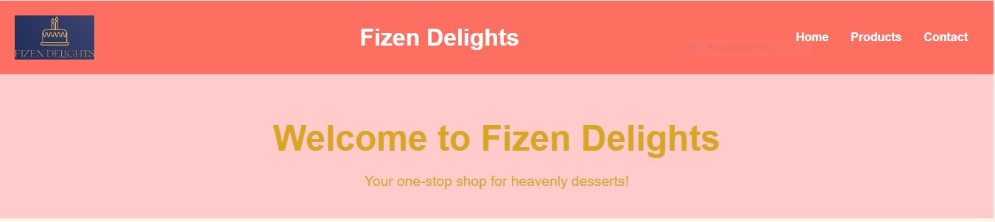

**MAIN PAGE :**

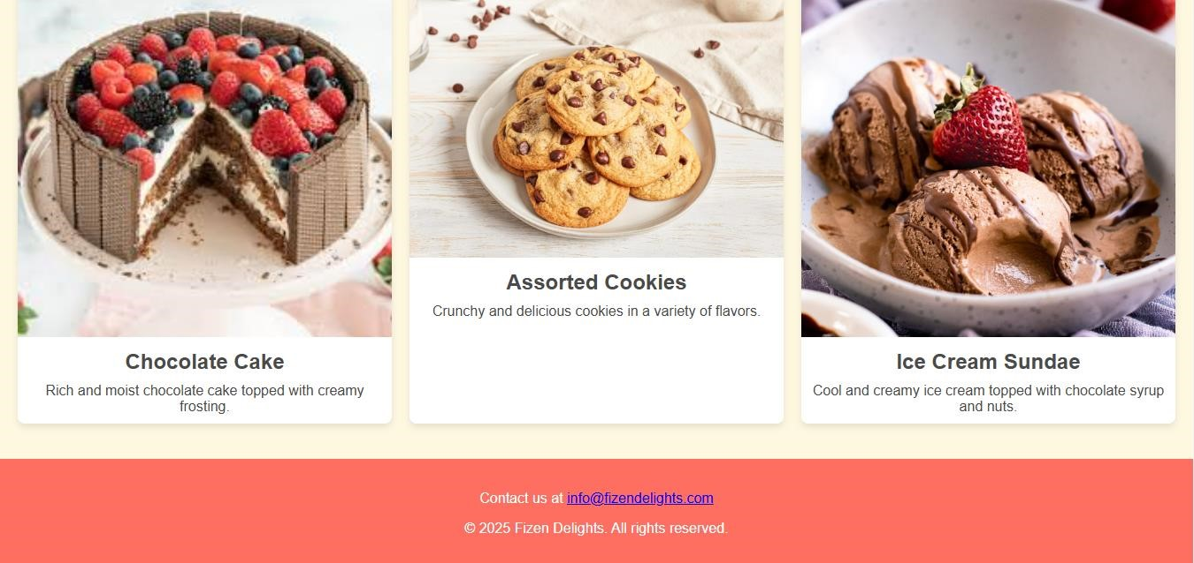

**PROJECT DONE BY** :

1.Karthika shree k

2.Madhumitha m

**GITHUB LINK** :

<https://github.com/karthika-runa/karthika-runa>